Patent Draft

on

Codefores Analyser

Submitted as a part of course curriculum for

# Bachelor of Technology

in

# Computer Science



## Priyanshi Priyanshu Raj Sagar Srivastava

2000290120117 2000290120119 2000290110138

[priyanshi.2024cs1172@kiet.edu](mailto:sanjeev.2024cs1054@kiet.edu) [priyanshu.2024cs1113@kiet.edu](mailto:rahul.2024cs1043@kiet.edu) [sagar.2024csit1162@kiet.edu](mailto:priyanshu.2024cs1112@kiet.edu)

## Under the Supervision of

Sreesh Gaur

Professor

# KIET Group of Institutions, Ghaziabad Department of Computer Science

**Dr. A. P. J. Abdul Kalam Technical University**

**2023-2024**

# TABLE OF CONTENTS

|  |  |
| --- | --- |
|  | Page  No. |
| TITLE PAGE .................................................................................................................... | i |
| DECLARATION .............................................................................................................. | ii |
| CERTIFICATE …........................................................................................................... | iii |
| ACKNOWLEDGEMENT.................................................................................................. | iv |
| CHAPTER 1 INTRODUCTION | 1-4 |
| 1.1. Introduction ……………………................................................... | 1 |
| 1.2 Problem Statement .……………………....................................... | 2 |
| 1.2. Objective………………………………………………………… | 3 |
| 1.3. Scope…………………………………………………………….. | 4 |
| CHAPTER 3 PROPOSED METHODOLOGY …………………………………........ | 5 |
| 3.1 Flowchart |  |
| CHAPTER 4 CLAIMS ………..………………………..…………………………… | 6 |
| CHAPTER 6 CONCLUSION …....................................................................................... | 7 |

# DECLARATION

We hereby declare that this submission is our work and that, to the best of our knowledge and belief, it contains no material previously published or written by another person nor material which to a substantial extent has been accepted for the award of any other degree or diploma of the university or other institute of higher learning, except where due acknowledgement has been made in the text.

Signature of Students

## Priyanshi Priyanshu Raj Sagar Srivastava

2000290120117 2000290120119 2000290110138

Date: 06-Sept-2023

# CERTIFICATE

This is to certify that Project Report entitled “**Codeforces Analyser**” which is submitted by **Priyanshi, Priyanshu Raj and Sagar Srivastava** in partial fulfilment of the requirement for the award of degree B. Tech. in Department of Computer Science of Dr A.P.J. Abdul Kalam Technical University, Lucknow is a record of the candidates own work carried out by them under my supervision. The matter embodied in this report is original and has not been submitted for the award of any other degree.

**Date: 06-Sept-2023 Supervisor Signature**

Sreesh Gaur

(Professor)

# ACKNOWLEDGEMENT

It gives us a great sense of pleasure to present the synopsis of the B.Tech Mini Project undertaken during B.Tech. Third Year. We owe a special debt of gratitude to Sreesh Gaur

(Professor), Department of Computer Science, KIET Group of Institutions, Delhi- NCR, Ghaziabad, for his/her constant support and guidance throughout the course of our work. His sincerity, thoroughness and perseverance have been a constant source of inspiration for us. It is only his/her cognizant efforts that our endeavours have seen the light of the day.

We also take the opportunity to acknowledge the contribution of Dr. Ajay Kumar Shrivastava, Head of the Department of Computer Science, KIET Group of Institutions, Delhi- NCR, Ghaziabad, for his full support and assistance during the development of the project. We also do not like to miss the opportunity to acknowledge the contribution of all the faculty members of the department for their kind assistance and cooperation during the development of our project.

Last but not the least, we acknowledge our friends for their contribution to the completion of the project.

# INTRODUCTION

The "Codeforces Analyser" project is a dedicated code repository that offers a streamlined solution for Codeforces online judge users. Leveraging the capabilities of the Codeforces API, this project presents a user-friendly analytics and visualization site. With Codeforces Analyser, users can seamlessly visualize, analyze, and compare Codeforces user profiles, gaining valuable insights into their competitive programming journey.

Some of the standout features of this project include the ability to compare maximum and minimum ratings, track the number of contests in which a user has participated, and identify their highest positive rating achieved. This tool is designed to empower Codeforces enthusiasts, helping them gauge their performance, identify areas for improvement, and benchmark themselves against their peers.

Whether you're a seasoned competitive programmer looking to fine-tune your skills or a newcomer seeking to understand your progress on Codeforces, Codeforces Analyser is the ideal resource for visualizing and comprehending your journey in the competitive coding arena.

# PROBLEM STATEMENT

To create a robust analytics and visualization tool for users of the Codeforces online judge platform for developing a code repository that utilizes the Codeforces API to provide users with the ability to visualize, analyze, and compare Codeforces user profiles.

The Codeforces Analyser project seeks to address the following core challenges:

* **Limited User Profile Insights:** Currently, Codeforces provides limited visualizations and statistics about user profiles. Users lack comprehensive tools to analyze their performance trends, identify strengths and weaknesses, or benchmark themselves against others.
* **Difficulty in Comparing User Profiles:** There is no built-in feature for comparing multiple Codeforces user profiles. This project aims to bridge that gap by enabling users to compare key metrics across different profiles effortlessly.
* **Lack of Peak Performance Analysis:** Users are unable to easily track their highest positive rating achieved over time, limiting their ability to gauge their progress effectively.

# OBJECTIVES

The primary objective of the Codeforces Analyser project is to create a user-friendly analytics and visualization platform that leverages the Codeforces API to enable users to:

1. Visualize and understand their competitive programming journey on Codeforces.
2. Analyze their performance trends, including rating history and contest participation.
3. Compare their Codeforces profiles with those of other users.
4. Identify areas for improvement and set performance goals.
5. Track and visualize their highest positive rating achieved over time.

In essence, this project aims to enhance the Codeforces user experience by providing valuable insights, encouraging healthy competition, and fostering a sense of community among competitive programmers on the platform.

# SCOPE

1. **User Profile Visualization :** The Codeforces Analyser will allow users to input Codeforces usernames and retrieve detailed visual representations of their profiles. These visualizations should include key statistics such as rating history, contest participation trends, and solved problems distribution.
2. **Compare Max/Min Rating :** Users should be able to compare the maximum and minimum ratings achieved by multiple Codeforces users. This feature enables users to gauge the progress and consistency of their own performance or compare themselves to others.
3. **Contest Participation Analysis :** The tool should provide insights into the number of contests in which a user has participated. Users can track their competition history and assess their commitment to competitive programming.
4. **Max Positive Rating :** Users can identify and compare the highest positive rating achieved by themselves or other Codeforces users. This metric highlights the peak performance level and progress over time.

# METHODOLOGY

1. Use the Codeforces API to get data on the user profiles of interest. This data can include the user's rating, number of contests participated in, max positive rating, and other relevant information.
2. Visualize the data in a way that is easy to understand and interpret. This could involve creating charts, graphs, or other types of visualizations.
3. Analyze the data to identify trends and patterns. This could involve looking at the user's rating over time, their performance in different types of contests, or their strengths and weaknesses as a problem solver.
4. Compare the data of different users to see how they compare to each other. This could involve comparing their ratings, number of contests participated in, or other relevant information.

Here are some specific visualizations and analyses that could be done with the Codeforces Analyser:

* A chart showing the user's rating over time. This could help the user to track their progress and identify areas where they need to improve
* A graph showing the user's performance in different types of contests. This could help the user to identify their strengths and weaknesses as a problem solver.
* A table comparing the user's rating to the ratings of other users. This could help the user to see how they stack up against other Codeforces users.

The Codeforces Analyser could be a valuable tool for Codeforces users who want to track their progress, identify their strengths and weaknesses, and compare themselves to other users. It could also be a helpful tool for coaches and mentors who are working with Codeforces users.

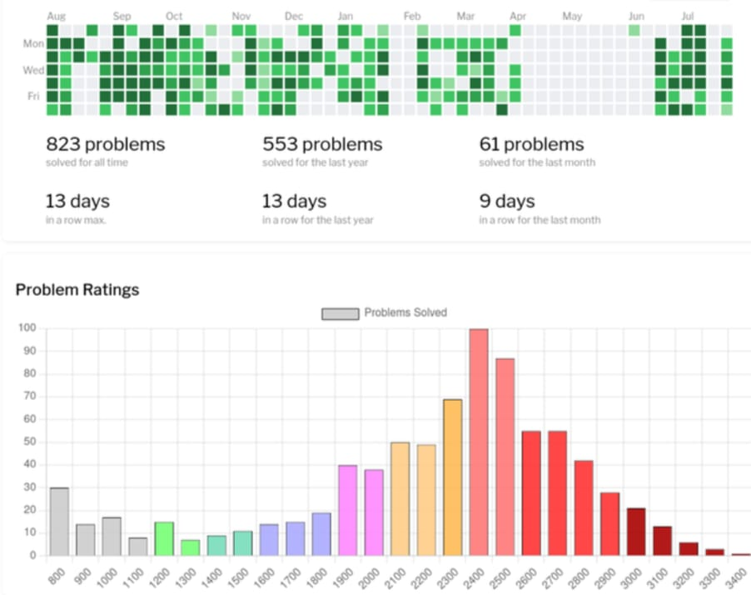

# CLAIM

**CLAIM 1: Empowers Codeforces Users** **-** The project empowers Codeforces online judge users by providing them with a versatile analytics and visualization platform.

**CLAIM 2: Comprehensive User Profiles -** Users can visualize, analyze, and compare Codeforces profiles, gaining insights into their competitive programming journey.

**CLAIM 3: Max/Min Rating Comparison -** The platform facilitates the comparison of maximum and minimum ratings, allowing users to assess their progress and consistency.

**CLAIM 4: Contest Participation Insights -** Users can track the number of contests participated in, helping them understand their competition history.

**CLAIM 5: Peak Performance Tracking -** The project enables users to identify and compare their highest positive rating achieved, providing a benchmark for their peak performance.

**CLAIM 6: Utilizes Codeforces API -** Leveraging the Codeforces API, the project ensures access to up-to-date and accurate user data.

**CLAIM 7: Promotes Healthy Competition -** By offering comparative analysis, the project fosters a sense of community and healthy competition among Codeforces users.

**CLAIM 8: Enhances User Experience -** Through data visualization and analytics, the project enriches the overall user experience on the Codeforces platform.

**CLAIM 9: Informs Goal Setting -** Users can make informed decisions and set performance goals based on the insights provided by the platform.

**CLAIM 10: Supports Continuous Improvement -** The project's user-centric approach allows for feedback collection and continuous refinement to meet evolving user needs.

PICTURE

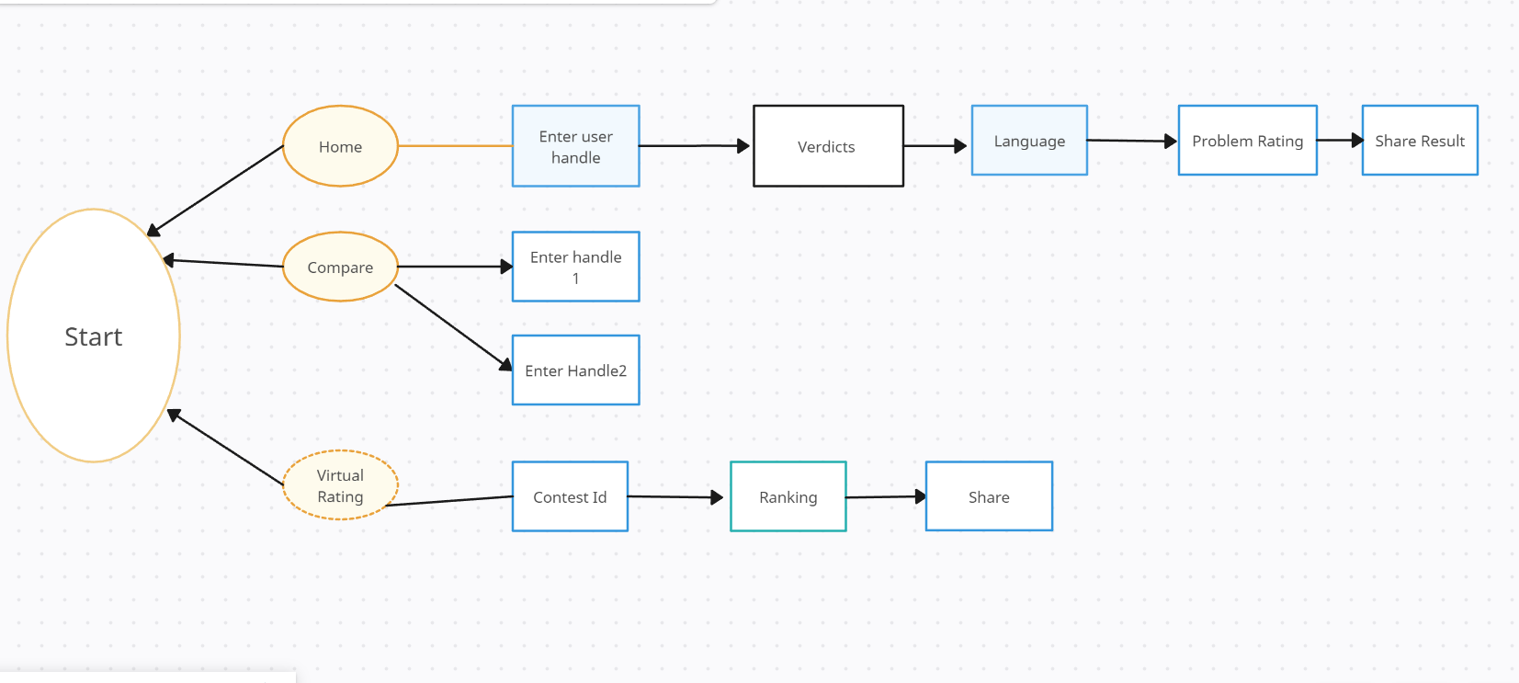

# CONCLUSION

The Codeforces Analyser project will result in a user-friendly web application or platform that empowers Codeforces enthusiasts to gain deeper insights into their competitive programming journey. By visualizing and comparing key performance metrics, users can set goals, identify areas for improvement, and foster a more competitive and informed community on Codeforces.

This tool will cater to both beginners seeking motivation and experienced programmers looking for detailed analytics to enhance their Codeforces experience. Ultimately, the Codeforces Analyser project aims to contribute to the growth and improvement of the competitive coding community on Codeforces.

It is a code repository for a simple analytics visualization site for Codeforces online judge users using Codeforces API. It can be used to visualize, analyze, and compare Codeforces user profiles. The project is still under development, but it has the potential to be a valuable tool for Codeforces users who want to track their progress, identify their strengths and weaknesses, and compare themselves to other users.